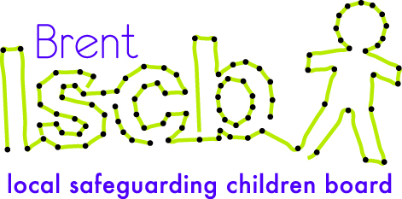

Brent Multi-agency Child Protection Conference Report Template

Guidance for Completing This Report
This report format has been designed in consultation with partner agencies to fit the format for child protection conferences in Brent. It is to be used by professionals to provide relevant information on the children and young people they are working with to be shared at both initial and review child protection conferences.
Please write the report based on your professional knowledge and understanding of the child(ren) and family. As this is a generic form you must ensure pertinent information from your agency or specialism is included. You need only to complete one report for all the relevant family members that you are working with.
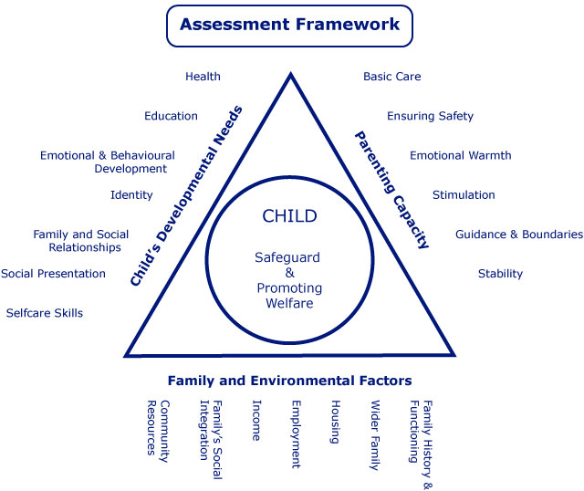
You may wish to refer to the Assessment Framework triangle to aid you assessment. Some examples of how the triangle can assist completing the five sections are:
Parenting capacity
A child is brought by parents to all appointments and attends all meetings concerning the child.
This should be entered as a strength.
Family and environmental factors
The family home is overcrowded and damp, and the parents have no recourse to public funds.
This should be entered as a complicating factor
Child’s Developmental Needs
Parents report that the child falls frequently thus causing lots of bumps and bruises. This has not been raised by them prior to the s.47 child protection enquiry. This should be entered as either a grey area (as it needs further assessment) or a current risk depending on the severity, frequency and location of the injuries, or can be entered under both.

As the previous example demonstrates, you may summarize the information into different categories, or sometimes in multiple categories at once. Do not get too concerned about whether you have placed the information into the right category as you may view the situation differently from that of others. What is important is that you ensure you capture all the salient points in your report. The conference Chair will summarize all information shared at the conference into the categories he or she deems most appropriate.

Submitting Your Report
Your report needs to be received by the conference team at least two working days in advance of the conference for the Chair to review and copies to be made.
If you submit your report by post, please send at least four working days in advance by first class or seven working days by second class in order to ensure your report is received in time. Please send your report to:
Conference Team
Brent Children and Families
Brent Civic Centre
Engineers Way
Wembley
HA9 0FJ

You may submit the report by email two working days before to: Child.protection@brent.gcsx.gov.uk

You may submit the report by fax two working days before to: 020 8937 4697
Please contact the conference team on 020 8937 3783 to confirm your report has been received.
Good Practice for Presenting at Conferences
In order to ensure that relevant information is shared at the conference in a timely manner, it is not feasible to read reports in their entirety during the conference. A copy of your report will be attached to the conference minutes and distributed to all agencies and family members invited to the conference. Therefore, we asked that you or your representative present only relevant aspects of the report within five minutes, and be familiar enough with its contents to be able to answer any further questions that may be asked. It neither looks professional nor inspires confidence when you are ill prepared or do not know the contents of your agency’s report or involvement with the family.
To save paper please do not send the above two pages with your report.
Brent Multi-agency Child Protection Conference Report
Agency’s Name |  | Agency reference ID:
Professional’s Name |  | Professional’s Designation
Professional’s Address |  | Professional’s Contact #
Social Worker’s Name |  | Social Worker’s Team
GP’s Name |  | GP Surgery

Child(ren)’s Details
Forename | Surname | NHS NO. | DOB | Address | Ethnicity | Disability or  Special Need | School or Nursery

Details of Parents, Carers or Significant Family or Household Members
Forename | Surname | DOB | Address | Ethnicity | Disability or Special Need | Relationship  to Child | PR?

Overview of your agency’s involvement with child/family

Include factors relevant to your service such as:
- purpose for your involvement
- level of engagement and attendance
- services or care provided
- difficulties or challenges
- referrals to other services
- progress to date
- duration of involvement
- any actions outstanding

Current Risks or Concerns

Include what factors you consider to pose risk of significant harm or increase the risk of harm to the child/children?
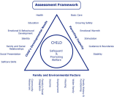

Historic or Complicating Factors
Include any previous history of concerns within the family, anything that might get in the way of resolving current risks and any previous involvement with your agency.
Safety / Protective Factors

Factors that you believe reduce the risks of harm to the child/children or help to ensure safety.

Strengths / Positives

Features of family life and parenting that have a positive effect on the children’s lives. Anything the parents/carers are doing well and if they were not, would be considered a risk factor.
Grey Areas

This should incorporate any areas that are unclear or may be of potential concern for the child(ren) but require further time, clarity, or assessment.

What do you believe to be the likely outcome for the child(ren) if their current situation continues?
What changes would you need to see in the family to assure you that the risk of harm to the children is sufficiently reduced?
What areas of risk or concern can your agency help the parents/carers to resolve?

Briefly describe what contribution your service can make to the child(ren)’s plan, who you could work with, and how you propose to undertake this work.

Report Completed By:
Author’s Name |  | Designation
Signature |  | Date
Manager’s Name |  | Designation
Signature |  | Date

Has this report been shared with the parents/carers? |  | Has this report been shared with the child(ren)/young person?

What are the views of the parents/carers and/or the child(ren)/young person on this report?

