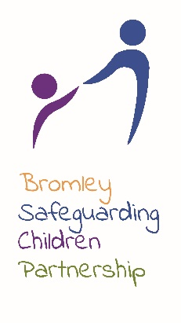
BSCP CASE REVIEW REFERRAL FORM

BROMLEY SAFEGUARDING CHILDREN PARTNERSHIP
Bromley Civic Centre, Stockwell Close, Bromley, Kent, BR1 3UH
Completed Form should be sent to BSCB Office at bscp@bromley.gov.uk.

BSCP CASE REVIEW REFERRAL FORM

There is an expectation that this referral has been agreed and evidenced within your agency and that it is likely to meet the SPR criteria or is sufficiently a serious incident to meet the criteria for a BSCP Multi-Agency Review.

Date of Referral:
Name of Referrer:
Referrer Agency:
Job Title:
Address/Email Address:

Telephone Number:

Name of notified BSCPBoard Member:

Case for consideration as:
Safeguarding Practice Review | Yes/No
Multi-Agency Learning Review | Yes/No
Date of death (if applicable)

First name and Surname DOB

Parents:

Children:

Family Address:

Child’s Ethnicity:

Any Disability?

Child currently subject to CP Plan (please state reason)?

Child previously subject to CP Plan (please state reason)?

Legal Status of child?

Agencies believed to be involved

Please provide details of the incident:

Please indicate why you feel this meets the criteria for a Safeguarding Practice Review/ Multi-agency Learning Review:

What supporting information have you attached to this referral? Please attach chronology.

Signed…………………………………………….. Date…………………….

Completed Form should be sent to BSCB Office at bscp@bromley.gov.uk.

