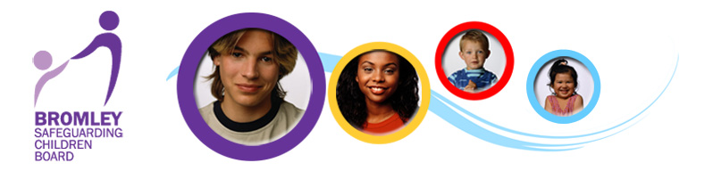

Protocol for Dealing with Allegations against Staff, Volunteers and Foster Carers who work with Children in Bromley

Contents

Introduction

1. Roles and Responsibilities

2. Procedures within the London Borough of Bromley

3. Suspension

4. Initial Considerations by the LADO

5. Strategy Meetings

6. Action if criminal investigation concludes with no prosecution or conviction

7. Sharing information for disciplinary purposes

8. Resignations and Compromise agreements

9. Record Keeping

10. Support

11. Timescales

12. Monitoring progress

13. Definitions of allegation outcomes

14. Unsubstantiated, false or malicious allegations

15. Substantiated Allegations

16. Learning lessons

17. Allegation Process Flowchart

18. Useful contacts

Introduction

This protocol is written in accordance with Chapter 7 of the London Child Protection Procedures 5th Edition 2015 – The management of allegations against staff or volunteers who work with children.

The protocol has been endorsed by Bromley Safeguarding Children Board (BSCB) and applies to any allegation or concern that a person who works with children in Bromley, in connection with his/her employment or voluntary activity, has:

  - behaved in a way that has harmed a child, or may have harmed a child;
  - possibly committed a criminal offence against or related to a child; or
  - behaved towards a child or children in a way that indicates s/he would pose a risk of harm if they work regularly or closely with children

These behaviours should be considered in the context of the four categories of abuse which are:

- Emotional abuse
- Physical Abuse
- Neglect
- Sexual Abuse

The procedures outlined in this document apply to cases where it is alleged there may have been inappropriate contact or relationships between staff and young people such as sexual relationships, grooming, inappropriate contact via social media and the possession of indecent images of children.

The procedures also apply to allegations or concerns that are raised about a member of staff in his/her personal life where the concerns indicate the member of staff may pose a risk of harm to children s/he works with.

These procedures are to be used by all employers, agencies and organisations that employ staff to work with children and young people in either in a paid or unpaid capacity in the London Borough of Bromley.

Members of the general public who wish to report concerns about a professional working with children and young people are advised to contact the Multi-Agency Safeguarding Hub (MASH) for advice and information. The contact details for MASH can be found on the ‘Useful Contacts’ page

There may be occasions when concerns raised about the suitability of a person to work with children, also give rise to concerns about the person’s suitability to work with vulnerable adults. In these situations the Designated Adult Safeguarding Manager (DASM) will need to be consulted. The contact details for the Bromley DASM can be found on the ‘Useful Contacts’ page.

1. Roles and responsibilities

1.1 BSCB is responsible for:

- ensuring effective inter-agency procedures are in place
- monitoring and evaluating the effectiveness of those procedures

1.2 Local authorities should allocate a Local Authority Designated Officer (LADO) who has responsibility for the management and oversight of cases.
This includes:

- Coordinating the investigative process of individual cases
- Ensuring the investigation is conducted in accordance with procedures
- Liaising with the Police and other agencies
- Providing advice and guidance to employers
- Monitoring the progress of cases to ensure they are conducted in a timely fashion
- Ensuring the investigative process is consistent thorough and fair

1.3 All BSCB member organisations are required to identify a named senior officer with overall responsibility for:

- Ensuring the organisation operates in accordance with procedures
- Resolving any interagency issues
- Cooperating with the BSCB to provide any information on allegations that may be required

1.4 All employers, agencies and organisations that provide services for children should identify a senior manager to whom allegations within the organisation should be reported. They should also identify a deputy should an allegation be made in their absence.

1.5 The Detective Inspector of the Police Child Abuse Investigation Team (CAIT) that covers Bromley is required to:

- have strategic oversight of the arrangements within Bromley for managing allegations against staff
- liaise with BSCB on appropriate issues
- ensure compliance with procedures

1.6 A designated Detective Sergeant in CAIT should:

- liaise with the LADOs
- take part in strategy discussions and meetings
- review the progress of cases in which there is a police investigation
- share information on the completion of an investigation or any prosecution

1.7 All organisations which provide services for children, or provide staff or volunteers to work with or care for children in Bromley, should have their own procedures for handling allegations which are consistent with this protocol and the London Child Protection Procedures –5th Edition 2015

2. Procedures within the London Borough of Bromley

2.1 The Head of Quality Assurance is the senior officer with overall strategic responsibility for allegations management.

2.2 The operational roles and responsibilities of the Local Authority Designated Officer (LADO) rest with a Group Manager who is also the Lead Officer for Education Safeguarding and is assisted in this role by a Deputy Group Manager LADO. Both positions are situated within the Quality Assurance service.

2.3 All employers must inform the LADO of all allegations that meet the criteria within one working day of the allegation being made, prior to any further investigation being carried out.

2.4 The criteria for reporting allegations is if the adult has:

    - behaved in a way that has harmed a child, or may have harmed a child;
    - possibly committed a criminal offence against or related to a child; or
    - behaved towards a child or children in a way that indicates s/he would pose a risk of harm if they work regularly or closely with children

2.5 The employer should not:

- Investigate the allegation
- Ask leading questions if seeking clarification
- Make assumptions or offer alternative explanations
- Promise complete confidentiality

2.6 The LADO will provide advice about:

- When and how much information is to be shared with the parents/carers of the young person
- How much information should be shared with the young person concerned
- If and how much information should be shared with the accused person
- Any modifications to the accused person’s working arrangements including suspension

2.7 If the child has sustained an injury the parents will need to be told and medical attention sought for the child immediately.

3. Suspension

3.1 Suspension is a neutral act and it should not be automatic. It should be considered in any case where:

- There is cause to suspect a child is at risk of significant harm, or
- The allegation warrants investigation by the police, or
- The allegation is so serious that it might be grounds for dismissal

3.2 When deciding whether or not to suspend, consideration should be given to any potential risk of harm to the child/ren who are the subject of the allegation, and any other children the accused person may come into contact with through their work.

3.3 Only the employer has the power to suspend the accused person, however the LADO should seek the views of the police and Children’s Social Care and inform the employer. If the advice from the LADO is not followed this must be recorded and the reasons noted.

4. Initial Consideration by the LADO

4.1 There are three strands in the consideration of an allegation:

- A police investigation of a possible criminal offence
- Social care enquiries and/or assessment about whether a child is in need of protection or services
- Consideration by an employer of disciplinary action

4.2 The LADO will discuss with the employer whether there is evidence that the allegation is demonstrably unfounded or malicious. If the allegation is not demonstrably false the LADO will consider whether there is need to obtain further information and advise the employer how and from whom this information should be sought.

4.3 The LADO will also advise the employer who is to be told of the allegation, what information is to be shared and what action can be taken to safeguard the alleged victim/s, and any other young people the accused person has access to through their work.

4.4 The LADO will in consultation with the employer, Children’s Social Care and CAIT decide whether the concern meets the threshold to convene a child protection complex strategy meeting.

4.5 Consultations known as strategy discussions are held by the LADO and Children’s Social Care with CAIT to determine whether the reported concerns meet the threshold for a criminal investigation by the police.

4.6 After initial consideration the LADO may decide the reported concerns do not require police or Children’s Social Care action but do require further investigation. In these circumstances the LADO will refer the matter back to the employer for an internal management investigation.

5. Strategy meetings

5.1 If the reported concerns indicate a professional may have harmed a child, and a crime has possibly been committed, there will need to be a child protection investigation. A complex strategy meeting is then convened by the LADO. The purpose of the complex strategy meeting is to gather, share and consider the available evidence, decide how best to respond to the concerns and plan any subsequent investigation.

5.2 The employer of the accused person is invited to attend the meeting along with representatives from any of the following agencies depending on the nature of concern, and where and in what capacity the accused person is employed:

- CAIT
- Children’s Social Care manager and social worker
- Designated/Named Safeguarding Health Professional
- Consultant Paediatrician
- Legal adviser
- OFSTED
- Relevant regulatory body
- Human Resources
- Designated/Lead Safeguarding Adviser
- Media Communications Officer

5.3 In Bromley the vast majority of these complex strategy meetings are chaired by one of the LADOs.

5.4 The LADO will ensure that the relevant Named/Lead Senior Officer and or regulatory body (i.e. OFSTED) for other organisations will be made aware of allegations that meet the threshold for a complex strategy meeting.

5.5 The LADO will also ensure the Head of Children’s Safeguarding and Quality Assurance, the Assistant Director for Education and the Named Senior Officer for other organisations, are made aware of allegations that are politically sensitive or that may attract media or public attention.

6. Action if criminal investigation concludes with no prosecution or conviction

6.1 If at any point during a police investigation, the LADO or the employer is informed the investigation is complete or there is to be no further action by the police or Crown Prosecution Service, the LADO should discuss with the employer the next steps to be taken. The discussion should take into account all the information gathered during the investigation and the different standards of proof between disciplinary and criminal proceedings. The options to be discussed will range from no further action to dismissal or cessation of use of the accused person’s services in the future.

6.2 If formal disciplinary action is not required, appropriate action should be instituted within three working days after the end of the investigation. If a disciplinary hearing is required and can be held without further investigation, the hearing should be held within 15 working days.

6.3 If further investigation is needed to decide upon disciplinary action, the employer and LADO should discuss whether the employer has appropriate resources or needs to commission an independent investigation because of the nature/complexity of the case and/or in order to ensure objectivity.

6.4 The investigating officer should aim to provide a report within 10 working days. On receipt, the employer should decide whether a disciplinary hearing is needed within 2 working days & if so it should be held within 15 working days.

7. Sharing information for disciplinary purposes

7.1 Wherever possible police & CSC should during the course of their investigations and enquiries, obtain consent to provide the employer and/or regulatory body with statements/evidence for disciplinary purposes.

7.2 If the police/CPS decide not to charge, or decide to administer a caution, or the person is acquitted, the police should pass all relevant information to the employer without delay.

7.3 If the person is convicted, the police should also inform the employer and the LADO straight away so that appropriate action can be taken.

8. Resignations and “Compromise agreements”

8.1 Every effort should be made to reach a conclusion in all cases even if:

- The accused person refuses to cooperate, having been given full opportunity to answer the allegation and make representations
- It may not be possible to apply any disciplinary sanctions
- The accused person’s period of notice expires before the process is complete
- It proves difficult to reach a satisfactory conclusion

8.2 “Compromise agreements” must not be used i.e. where a person agrees to resign on the condition there is no disciplinary action, and a future reference is agreed.

9. Record keeping

9.1 Details of allegations that are found to have been malicious should be removed from personnel records However, for all other allegations it is important that a clear and comprehensive summary of the allegation, (how it was followed up and resolved, decisions reached, and action taken) is kept on the accused person’s confidential personnel file and a copy given to the individual. It should be kept until the person reaches normal retirement age or for 10 years if longer.

9.2 The purpose of the record is to:

- Enable accurate information to be given in response to future reference requests
- Provide clarification where a DBS disclosure reveals an allegation that did not result in a prosecution or a conviction
- Help prevent unnecessary re-investigation if the allegation should resurface

10. Support

10.1 The organisation, together with Children’s Social Care (CSC) and the police (if they are involved), should consider providing support for children who may have suffered significant harm or who are involved in a case where criminal prosecution is possible.

10.2 Parents/carers of the child/ren involved should be:

- Informed of the allegation as soon as possible provided this does not impede the enquiry, disciplinary or investigative processes (they may need to be told straight away e.g. if child injured & requires medical treatment)
- Kept informed about the progress of the case
- Told the outcome where there is no criminal prosecution (including the outcome of any disciplinary process but excluding the deliberations/information used in a hearing)

10.3 Children and their parents/carers should:

- Be helped to understand the processes involved
- Told the result of any enquiry or disciplinary process
- Where necessary, be helped to understand the outcomes reached

10.4 The accused person should be:

- Treated fairly & honestly & helped to understand the concerns expressed & processes involved
- Kept informed of the progress of the case & the outcome of any investigation and the implications for disciplinary or related processes.
- Provided with appropriate support during the case (via occupational health or employee welfare arrangements where those exist)
- Be kept informed about developments in the workplace if suspended
- Advised at the outset to contact his/her union or professional association

10.5 If a suspended person is to return to work, the employer should consider appropriate help/support e.g. phased return and/or provision of a mentor. Consideration should also be given to how best to manage the person’s contact with the child/ren who made the allegation, if still in the workplace.

11. Timescales

11.1 The LADO should be told of all allegations meeting the criteria outlined above within one working day.

11.2 If the allegation meets the threshold for a complex strategy meeting the LADO will make every effort to convene a meeting within three working days, subject to the availability of those required to attend.

11.3 A police officer receiving an allegation should without delay report it to the designated liaison officer who in turn should report it to the LADO straight away.

11.4 Similarly members of the Multi Agency Safeguarding Hub (MASH) or other Children’s Social Care officers should report allegations to the LADO without delay.

11.5 It is an expectation of the BSCB that 80% of investigations are resolved within 1 month, 90% within three months and all but the most exceptional cases are resolved within twelve months.

11.6 It is recognized that it is unlikely that cases requiring a criminal prosecution can be completed in less than three months.

12. Monitoring progress

12.1 The LADO should provide advice, support and guidance as required or requested throughout the investigative process and review, monitor and record the progress of each case either fortnightly or monthly depending on the complexity of the case/ investigation.

12.2 This could be by way of review strategy discussions, evaluations or direct contact with the police, Children’s Social Care or the employer as appropriate. Where there is a police investigation, review dates should be set and agreed with the police. Where the target timescales cannot be met the LADO should record the reasons.

12.3 The police can consult the Crown Prosecution Service (CPS) at any stage about the evidence needed to charge a person, but they should also set target dates for reviewing the progress of the investigation & consulting the CPS about charging or continuing/closing the investigation. Wherever possible this should be no later than 4 weeks after the strategy meeting/ initial evaluation and fortnightly or monthly thereafter, if the investigation continues.

13. Definitions of allegation outcomes

False: there is sufficient evidence to disprove the allegation

Malicious: there is sufficient evidence to disprove the allegation and there has been a deliberate act to deceive

Substantiated: there is sufficient evidence to prove the allegation

Unsubstantiated: this is not the same as a false allegation It means there is insufficient evidence to prove or disprove the allegation; therefore the term does not imply guilt or innocence

14. Unsubstantiated, false or malicious allegations

14.1 False or malicious allegations are rare, however if an allegation is determined to be false or malicious the employer in consultation with the LADO should:

- refer the matter to CSC to determine whether the child is in need of services, or may have been abused by someone else
- ask police to consider what action may be appropriate

14.2 Where there is insufficient evidence to substantiate an allegation the LADO will refer the matter back to the employer for a management investigation or for consideration about what if any further action is required.

15. Substantiated allegations

15.1 If an allegation is substantiated and the accused person is dismissed or the employer ceases to use the person’s services or the person resigns or otherwise ceases to provide his/her services, the LADO should discuss with the employer whether a referral should be made to the Disclosure and Barring Service (DBS).

15.2 The LADO should also advise whether it is appropriate to make a referral to a relevant professional or regulatory body i.e. Health and Care Professions Council, OFSTED, General Medical Council or National College for Teaching and Leadership.

15.3 If a referral is appropriate it should be made within one month of the allegation being substantiated.

16. Learning lessons

16.1 If an allegation is substantiated, the employer and the LADO should review the circumstances of the case to determine whether there are any improvements to be made to the organisation’s procedures or practice to help prevent similar events in the future.

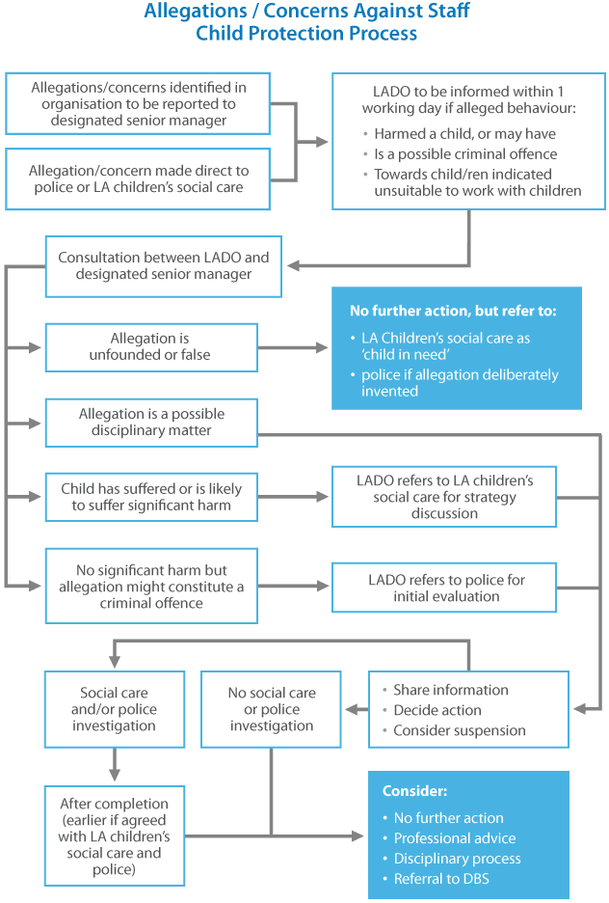

(London Child Protection Procedures 5th Edition 2015-London Safeguarding Children Board)

USEFUL CONTACTS

If you wish to report an allegation against a member of staff who has/may have:

- Behaved in a way that has harmed a child, or may have harmed a child;
- Possibly committed a criminal offence against or related to a child; or
- Behaved towards a child or children in a way that indicates s/he would pose a risk of harm if they work regularly or closely with children

Please contact one of the following:

Local Authority Designated Officer (LADO) Tele: 0208 461 7669
Lead Officer for Education Safeguarding Email: LADO@bromley.gov.uk
Group Manager – Quality Assurance Service

Deputy LADO Tele: 0208 313 4325
Deputy Group Manager Email: LADO@bromley.gov.uk

For a Notification of an Allegation Referral Form please contact:

Quality Assurance Business Support Tele: 0208 313 4325

Other Useful Contacts:

Multi Agency Safeguarding Hub (MASH) Tele: 0208 461 7373 / 7379
Referral and Assessment Service
Children’s Social Care

Out of Hours Emergency Duty Team Tele: 0300 303 8671
Children’s Social Care

Police Child Abuse Investigation Team Tele: 0207 230 3700
Bromley

Designated Adult Safeguarding Manager Tele: 0208 461 7777

