Published April 2018
Updated May 2023
BSCP Neglect Toolbox
Introduction

Safeguarding is not a paper exercise, it’s not about ticking the right number of boxes, critically it is about the application of professional judgement. This simple toolkit has been designed for our multi-agency safeguarding community as an aid to help guide and focus thinking. Knowing what to look for, what to do and how to seek help when you suspect a child may be suffering from neglect is key. Please use this toolkit to help focus on the questions you should ask and the actions you could take.

Neglect Indicators and Bromley Thresholds of Need

Neglect can be difficult to identify. Isolated signs may not mean that a child is suffering neglect, but multiple and persistent signs over time could indicate a serious problem. It is common for evidence of neglect to present through signs and symptoms which may be noticed by different agencies in relation to different children in the family at different points in time.
The Bromley Threshold of Need Guidance (2021) uses the pan-London threshold of needs indicators. Indicators of neglect appear in all three sections (child’s development, environmental factors, parenting/family factors). All practitioners should be familiar with this key document and use it when making referrals. Below is an excerpt from the continuum of need matrix (indicator) section:
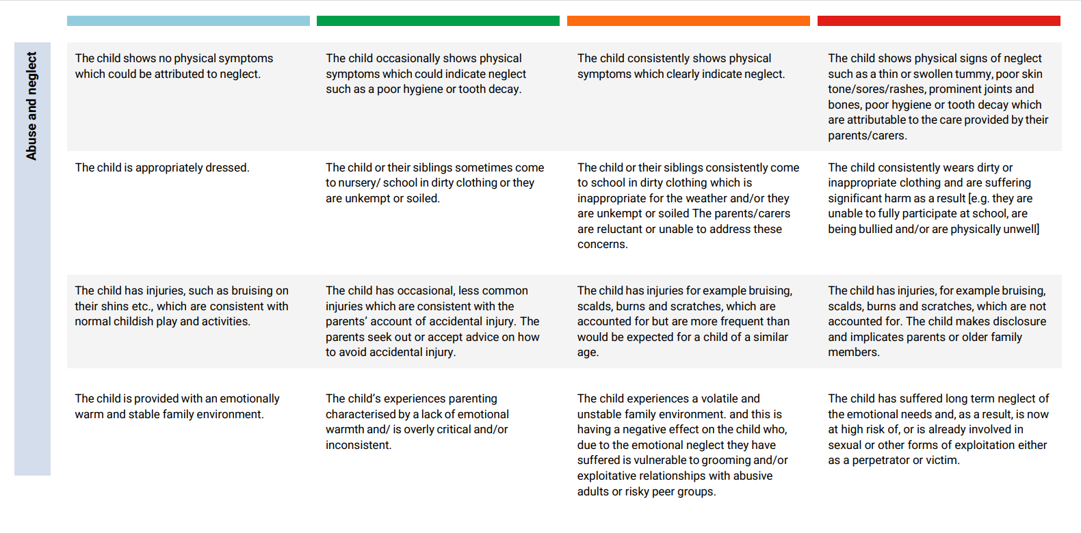
Pages 8-11 of the NSPCC Core info leaflet ‘Neglect Matters’ shares how you can recognise neglect and states the consequences of it, by age group.
-------------------------------------------------------------------------------------------------------------------------------------

Identifying and Assessing Neglect

It is important that children and young people receive the right service at the right time and this is supported by Working Together 2018. In order for this to happen, all professionals who have contact with children, young people and families have a duty of care to identify issues at the earliest opportunity and assess what intervention is required.
Assessment should be a dynamic process that identifies analyses and responds to the changing nature and level of need and/or risk faced by a child. A good assessment will enable practitioners to intervene at the right time with the right level of support and to monitor and record the impact of any services delivered to the child and family. Continuous assessment is crucial in ensuring that the help and support being delivered is having the intended impact.
This multi-agency neglect assessment toolbox has been developed to support practitioners to undertake effective assessments that enable them to accurately identify appropriate cases in need of early help or onward referral to Children’s Social Care. The tools included should also be used to review the effectiveness of the support plans that are in place and the outcomes for the child/ren.
Using the assessments early in intervention will hopefully support positive outcomes for children, meaning onward referral may not be required.

Who should use the toolbox?
These tools are available for any services, schools or organisations who work with children and families in the London Borough of Bromley.

All professionals need to be familiar with the tools provided and know when and how to use them.

Managers should facilitate practitioner’s attendance at relevant training events to support the use of these tools and seek assurance in supervision that they are completed where appropriate.

Why is it needed?
Learning from reviews and thematic inspections frequently highlight missed opportunities as a consequence of poor quality assessments and lack of early intervention.

The 2018 Working Together guidance lists some of the following as features of a high quality assessment:

- They are child-centred and informed by the views of the child.
- Decisions are made in the best interests of the child.
- They are rooted in child development and informed by evidence.
- They build on strengths as well as identifying difficulties.
- They ensure equality of opportunity and a respect for diversity including family
structures, culture, religion and ethnic origin.

These principles should be applied when completing any of the assessments within this toolbox.

Wishes and feelings of the child -It is important when completing any assessments that the wishes and feelings of the child are listened to throughout. Professionals need to ensure the voice of the child runs through everything we do. Seeking the views of the child will ensure that there is not over reliance on parental accounts which can therefore minimise the risk of disguised compliance.

These tools are there to be used when you are concerned that the quality of care of a child you are working with suggests that their needs are being neglected. It will help you to reflect on the child’s circumstances and will help you put your concerns into context and identify strengths and resources.

--------------------------------------------------------------------------------------------------------------------------------------

BSCP assessment tools

- BSCP Thresholds Document

- Chronology guide

A chronology will help you to describe concerns if you suspect neglect and collate evidence. This simple chronology template can be used by any organisations who do not already have a recording structure in place.

More assessment resources

The Department of Health developed a pack of tools and resources that can be used to support evidence based practice and assessments. Although developed in 2000, they can still be a helpful tool for practitioners to use to support evidence-based practice when working with neglect.
Double click on each PDF and check the bottom bar of your computer to see the PDF. This Word document must be Edit Enabled in order for these to open.

The Family Pack of Questionnaires and Scales

- Parenting daily hassles scale
An assessment tool which can be used with the parents/carers to consider their view of the children’s needs and how they are coping with these needs.
- Strengths and difficulties
The Strengths and Difficulties Questionnaire (SDQ) is a brief behavioural screening tool to consider whether a child or young person has emotional or behavioural difficulties. The questionnaire can be completed with the parents/carers and also other professionals such as teachers.

- Home conditions assessment
An assessment tool which can be used if making a home visit where there have been concerns about neglect and poor home conditions.
- Clutter Image Rating
The Clutter Image Ratings can be used to assess the condition of a hoarded home as well as the hoarder’s level of insight:

http://hoardingdisordersuk.org/wp-content/uploads/2014/01/clutter-image-ratings.pdf

--------------------------------------------------------------------------------------------------------------------------------------
Practical tools
Helpful resources and information to support practice, including links to the NSPCC core info leaflets which were produced with the Royal College of Paediatrics and Child Health (RCPCH):

- Core info leaflets
  - Neglect Matters: What you need to know about neglect; a guide for parents, carers and professionals includes list of possible signs of neglect
  - Home alone
  - Emotional neglect and emotional abuse in pre-school children - NSPCC
  - Neglect or emotional abuse in children aged 5-14 – NSPCC
  - Neglect or emotional abuse in teenagers aged 13-18 - NSPCC

--------------------------------------------------------------------------------------------------------------------------------------

Training materials

The Department for Education developed resources for training multi-agency participant groups in identifying and dealing with child neglect. Although published in 2012 they are still relevant.

- Childhood neglect: training resources
  - Childhood neglect: improving outcomes for children – guidance for trainers
  - Childhood neglect: improving outcomes for children – the framework
  - Training resources on childhood neglect: exercises and guidance
  - Training resources on childhood neglect: presentations and notes
  - Training resources on childhood neglect: handouts
  - Training resources on childhood neglect: family case studies

The BSCP runs a one day, live learning training course on complex neglect for the children’s workforce in Bromley. See the BSCP training programme for more information on content and how to book.

Our Level 1 ‘Safeguarding Children’ online e-learning module covers neglect for all those workers/community members who may be in a position to spot neglect but do not work regularly with children. See the BSCP Online Training webpage to see how to access this training for free.

--------------------------------------------------------------------------------------------------------------------------------
Communications materials

BSCP and partner agencies may wish to raise awareness of neglect within its communications. Suggested copy is attached.

